 

Q1:

Software Requirements Specification

for

Pet Medical Appointment System

**Version 1.0 approved**

**Prepared by**

**Huynh Ngoc Bao Khanh – DE170163**

**FPT University – Da Nang Campus**

**Da Nang, March 26th, 2024**

Q2:

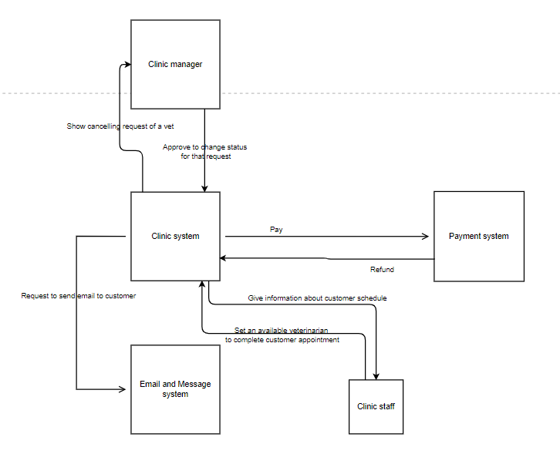

-External entities: Clinic manager, Payment system, Email and Message system, Clinic staff

Q3:

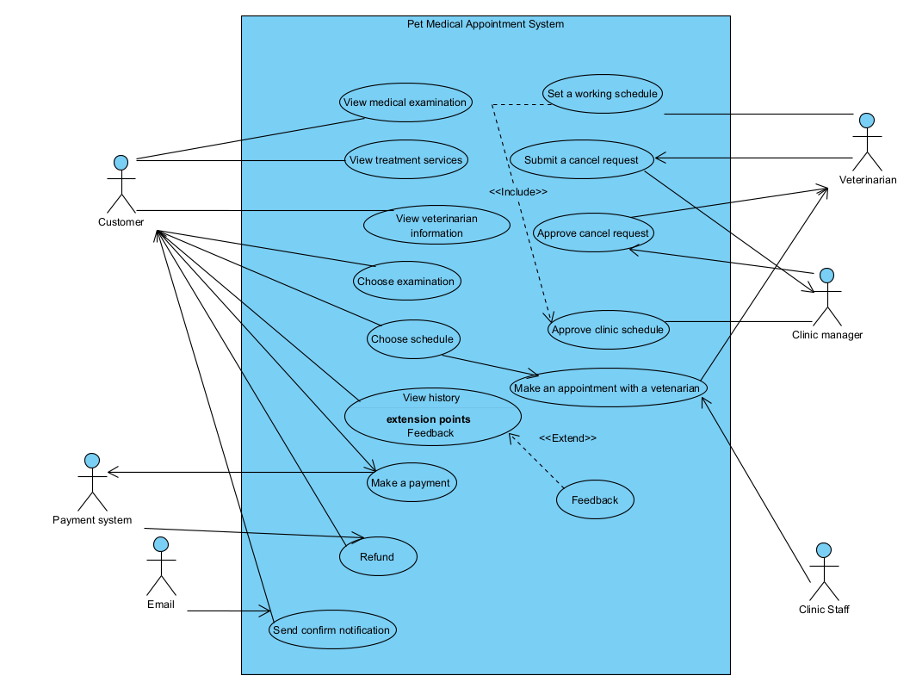

| **#** | **Actor** | **Description** |
| --- | --- | --- |
| 01 | Customer | Customer is the person who wants to make any appointment to Pet Medical Appointment System. A customer should be able to view details of medical examinations and treatment services, view vet information, choose examination, make an appointment, and make a payment,… |
| 02 | Clinic Staff | Clinic staff is the person who will manage all the schedules, including view customer appointments, change or cancel appointments after reaching agreement with the customer,… |
| 03 | Veterinarian | Veterinarian is the one who can register for a work schedule, and also can cancel their work schedule |
| 04 | Clinic manager | Clinic manager is the one who set the clinic schedule and approve or deny a cancel request from veterinarian. |
| 05 | Payment system | Payment system will receive payment from customer, and refund if the customer cancels the appointment |
| 06 | Email or message | The email or message system will send notification to customer to confirm appointment |

| **#** | **Use Case** | **Actors** | **Description** |
| --- | --- | --- | --- |
| UC-01 | View medical examination | Customer | Customer can view details of medical examination |
| UC-02 | View treatment services | Customer | Customer can view details of treatment services |
| UC-03 | Choose examination | Customer | Customer can choose an available examination |
| UC-04 | Choose a schedule | Customer | Customer can choose an available schedule of clinic or a veterinarian |
| UC-05 | View veterinarian | Customer | Customer can view details of a veterinarian |
| UC-06 | View history | Customer | Customer can view appointments history if there were any appointments |
| UC-07 | Feedback | Customer | Customer can give a feedback for a happened appointment |
| UC-08 | Make a payment | Customer | Customer can pay for the services |
| UC-09 | Send a notification | Email or Message system | Email or Message system will send a notification to confirm if the customer has made the appointment and committed to the appointment |
| UC-10 | Make an appointment to a veterinarian | Clinic staff | If the customer only choose the available schedule of the clinic without choosing a vet, clinic staff will match their schedule and make an appointment. This also include cancellation and modifying |
| UC-11 | Approve clinic schedule | Clinic manager | Clinic manager can approve the clinic schedule so that the customer can know an choose a schedule based on it |
| UC-12 | Approve cancel request | Clinic manager | Clinic manager can approve or deny cancel request about working schedule of a veterinarian |
| UC-13 | Set a working schedule | Veterinarian | Veterinarian can set a working schedule based on approved clinic schedule |
| UC-14 | Submit a cancellation of working schedule | Veterinarian | Veterinarian can submit a request to clinic manager about cancelling a working schedule. |
| UC-15 | Refund | Payment system | Payment system can refund to a customer who has cancelled the appointment |

Q4:

| **ID** | **Rule Definition** | **Use cases** |
| --- | --- | --- |
| BR-01 | The cancellation must be 24 hours before the time of appointment | UC-09 |
| BR-02 | The customer can get discounted for 15% when making an appointment for at least 2 pets | UC-08 |
| BR-03 | The customer must have history appointment to be able to feedback | UC-06, UC-07 |
| BR-04 | The network transactions details must have 256-bit encryption | UC-08, UC-15 |
| BR-05 | The cancellation of a working schedule must be approved by clinic manager | UC-12, UC-14 |
|  |  |  |

**Q5:**

a. The most important non-functional requirement:

- Performance: The system needs to be capable of handling significant traffic, accommodating approximately 100 individuals. This requirement is essential to ensure that all customers, clinic staffs, veterinarians, and clinic managers have reliable access.

b. The second important non-functional requirement:

- Security: Access control is critical, necessitating that only users with the correct roles, are granted the permissions to do their job. This ensures that the integrity and confidentiality of the clinic's resources are maintained effectively.